**DATA STRUCTURES**

**T2 – IMPLEMENTATION**

BATCH NUMBER: 22

REGISTRATION NUMBERS:

211FA18046

211FA18079

211FA18099

211FA18138

QUESTION:

Collect student data such as id, name, age and branch to build a linked list, and design a logic to implement the following operations such as printing the length of the linked list, and checking whether the data in the given liked list is in the form of palindrome or not, and if it not palindrome print that list in reverse order.

DESCRIPTION:

LINKED LIST:

Linked List is a simple data structure in programming, which obviously is used to store data and retrieve it accordingly. To make it easier to imagine, it is more like a dynamic array in which data elements are linked via pointers (i.e. the present record points to its next record and the next one points to the record that comes after it, this goes on until the end of the structure) rather than being tightly packed.

There are two types of linked list:

1. Single-Linked List: In this, the nodes point to the node immediately after it
2. Doubly Linked List: In this, the nodes not only reference the node next to it but also the node before it.

ALGORITHM:

BUILDING A LINKED LIST OF STUDENT DATA:

1)First, create a class Node with instance variables name, age, id, branch, next.

2)Now, I will create a class linked list with instance variable head.

3)The variable head points to the first element in the linked list and next indicates the next element.

4)Also, define name, age, id and branch.

5)In this way the student data is collected and displayed.

LINKED LIST PALINDROME OR NOT:

**1)** Get the middle of the linked list.

**2)**Reverse the second half of the linked list.

**3)** Check if the first half and second half are identical.

**4)**Construct the original linked list by reversing the second half again and attaching it back to the first half

5) If both halfs are not identical then we print the list in the reverse order.

LENGTH OF THE LINKED LIST:

1) Initialize count as 0

2) Initialize a node pointer, current = head.

3) Do following while current is not NULL

4) current = current -> next

5) Increment count by 1.

6) Return count

SOURCE CODES:

STUDENT DATA:

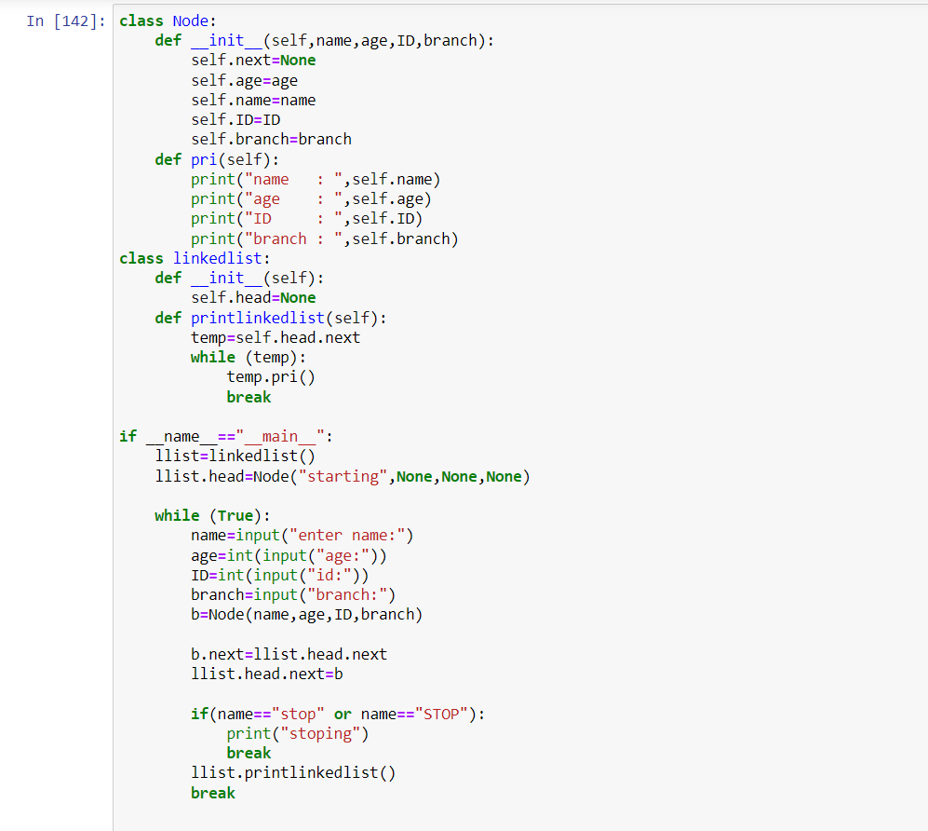

OUTPUT:

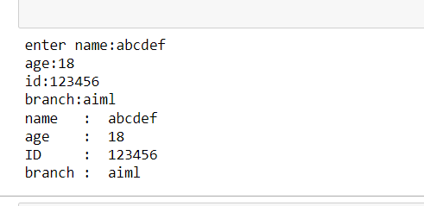

LENGTH OF THE LINKED LIST ,PALINDROME OR NOT:

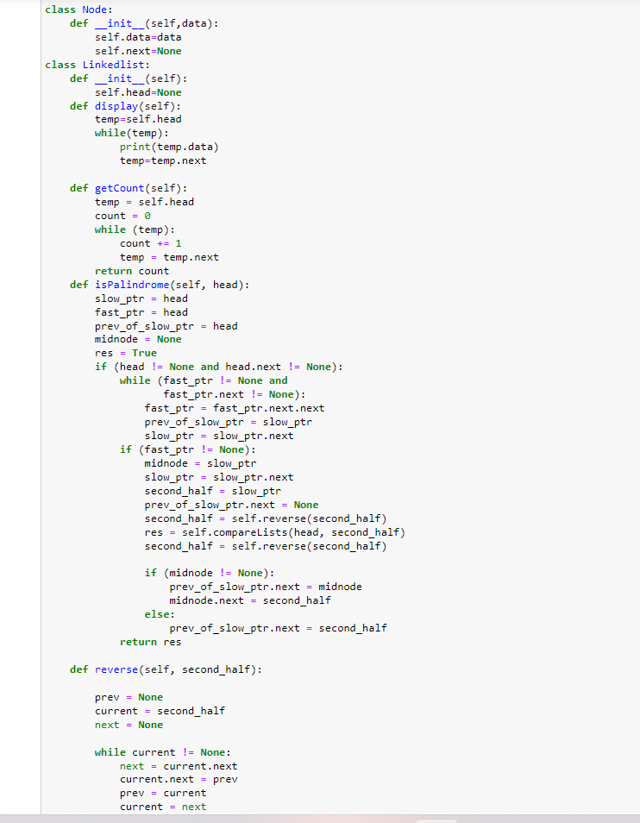

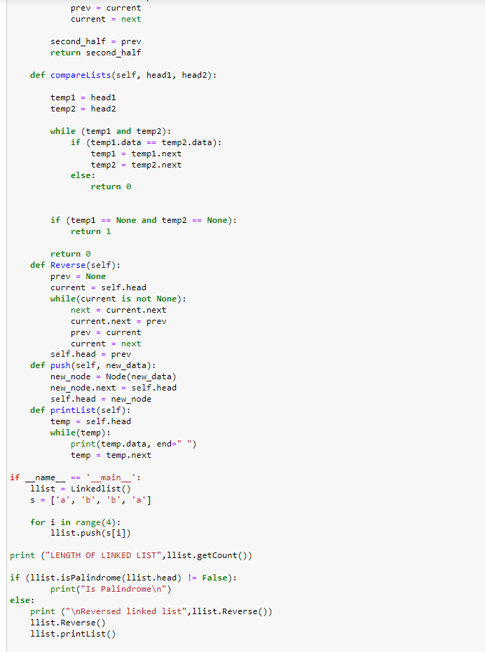

OUTPUT:

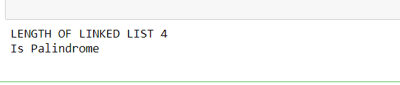

TEST CASES:

INPUT 1:

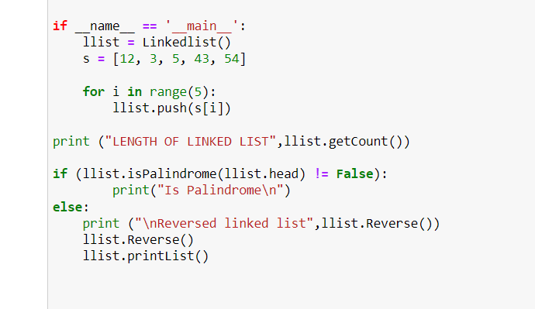

OUTPUT 1:

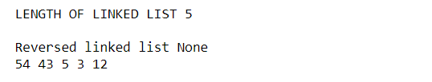

INPUT 2:

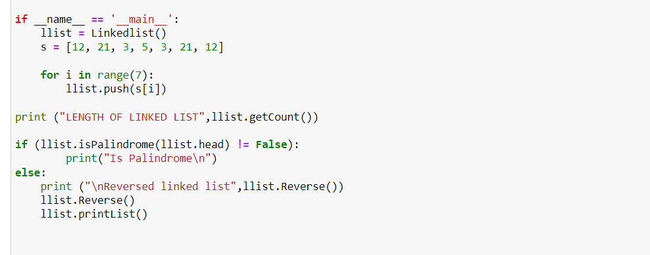

OUYPUT 2:



RESULT:

Using these codes we can collect the student data in a linked list, we can find whether the linked list is palindrome or not.